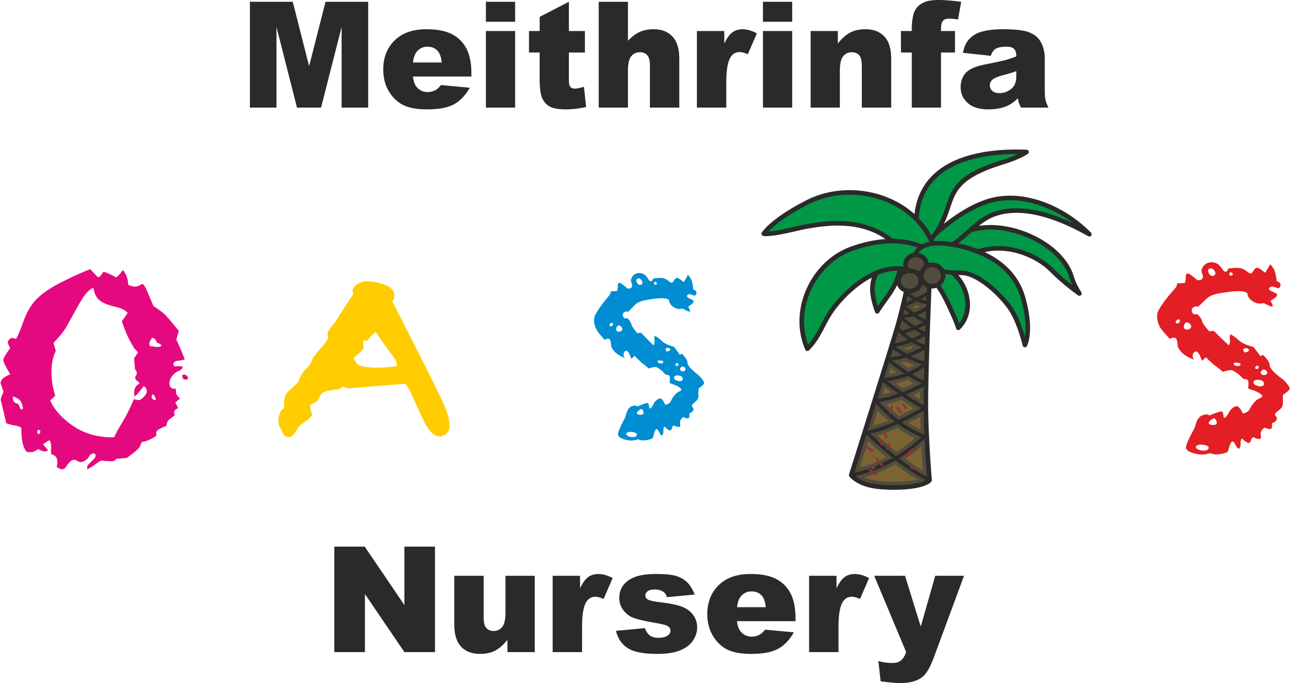

Play Policy

Play is a fundamental aspect of a child’s overall development; it is a critical factor in enriching learning and development. The nursery acknowledges the importance of play within the Early Years Foundation Phase (EYFP) ad incorporates play as a key element of the learning experience.

The nursery environment is developed using natural resources such as wooden blocks, pine cones and other open ended resources avoiding too much plastic. This is purposeful to help develop and inspire the children’s creativity and imagination during their play.

The nursery aims to ensure that:
- Play activities are freely chosen and the nursery will help to ensure that play is fun and enjoyable for children.
- All children have access to a balanced range of play with access to both the indoor and outdoor areas for the majority of the day. Times for outdoor play are allocated to make sure there is enough time for all groups to access the play.
- The nursery listens to children and aims to meet their needs in an inclusive way.
- The nursery recognises the need for play opportunities to be challenging whilst free from unnecessary hazards
- Staff create an environment that fosters opportunities to pay by setting up invitations and provocations.
- Our role as practitioners is to enable rather than direct the child in accordance with the four purposes of the curriculum for Wales.
- The nursery helps and supports parents/carers to understand the value of play in the overall development of children.

Outdoor learning
- The nursery believes that outdoor learning is essential to children’s health, development and well-being.
- Outdoor learning compliments indoor and outdoors enables children to make the most of resources and materials available to them and develop their ideas without unnecessary interruption. Consequently, it is vital that as an early years setting the nursery maximises the children’s opportunities outdoors.
- The outdoor learning environment is planned so that all seven areas of learning specified in the Early Years Foundation Phase can be met through play.
- The nursery aims to use our whole environment as an extension to our indoor classrooms so the children can freely use both indoors and outdoors. Statistics show that children are happiest when outside and thrive in the natural environment.
- Out outdoor areas are fully risk assessed and are and are checked on a daily basis. Staff follow correct procedures i.e. staff/child ratios, making sure areas are safe, monitoring play, etc.
- The nursery asks that all parents/carers be aware of out outdoor learning philosophy and dress their children appropriately for the weather conditions.
- The nursery encourages parents/carers to talk to any member of management if they have any concerns about outside play.

